

To order a ticket by mail, fill this form out completely and mail it, with payment to:

***South Vermillion Band Boosters***

***770 Wildcat Dr.***

***Clinton, IN, 47842***

Checks are to be made out to SV Band Boosters. Your ticket stub will be sent after your payment is processed.

2019-20 CAR RAFFLE ORDER FORM

Pride of South Vermillion Marching Wildcats Raffle

**Sample ticket**



[Grab your reader’s attention with a great quote from the document or use this space to emphasize a key point. To place this text box anywhere on the page, just drag it.]

**Name (Please print): ___________________________________**

**Address: _________________________________________**

**_________________________________________**

**Phone Number: _____________________________________**

**Email: ____________________________________________**

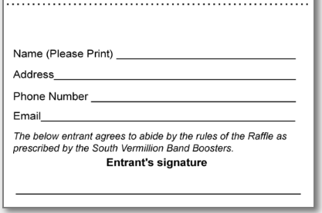

For Office Use:

Cash: $__________

Check: $__________

#__________

The below entrant agrees to abide by the rules of the Raffle as prescribed by the South Vermillion Band Boosters.

Entrant’s Signature

______________________________________________________________